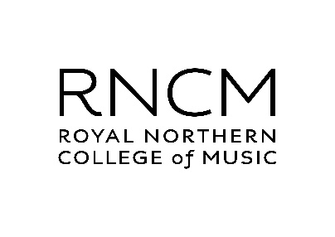

RNCM JOHN GOLLAND AWARD 2022

APPLICATION FORM

Please refer to the John Golland Award Competition Regulations document
before completing this application form.

FULL NAME …………………………………………………………………..

CONTACT ADDRESS …………………………………………………………………..

…………………………………………………………………..

…………………………………………………………………..

TELEPHONE NO ………………………………………………

E-MAIL ADDRESS ………………………………………………

DATE OF BIRTH * ….. / ….. / ……….

* To be eligible to apply for this Competition you must be between the ages of 18 and 30. Applications will be accepted from those born on or after 1 December 1991, AND on or before 30 November 2003.

TITLE OF SUBMISSION …………………………………………………………………..

PLEASE ATTACH THE FOLLOWING TO YOUR APPLICATION EMAIL:

- APPLICATION FORM

- FULL SCORE (digital)

- SOUND FILE (mp3 or equivalent)

- A SHORT CURRICULUM VITAE

Please send your documents to Harriet Lane, RNCM Programming Co-ordinator at harriet.lane@rncm.ac.uk, by midday on 30 November 2021.

