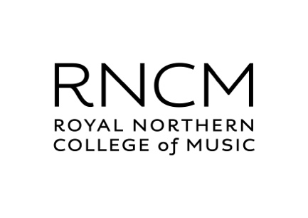
PGR Reference Request and Report (PhD)
To the applicant: Please complete this section of the form, then send a copy to each of the referees you have named in your application to RNCM. If you are applying for the Composition or Performance pathways, one referee should have knowledge of your recent academic work. If you are applying for the Music Education, Music Psychology or Musicology pathways, both referees should have knowledge of your recent academic work.

Name of applicant_________________________________________
Pathway:* Composition, Music Education, Music Psychology, Musicology, Performance
Signature of applicant______________________________________

***************************************************************************************
To the referee: Please provide a letter of reference in support of the above applicant as an attachment to an email from your institutional address to pgr@rncm.ac.uk, by 22 January 2024. It would be helpful if you could
i) say how long you have known the applicant and in what capacity;
ii) list their qualifications, describe their current level of performance (academic and/or musical) and predict the outcome of their current course of study, if appropriate;
iii) assess their potential for undertaking research in their chosen field, reflecting on their motivation, intellectual ability and capacity for original thinking;
iv) comment on their main strengths and weaknesses, as you perceive them;
v) if their first language is not English, gauge the extent to which it is likely to be adequate for writing a doctoral-level thesis;
vi) provide any other information that you think is or may be relevant.

Title and name of referee:* Prof./Dr/Mr/Ms______________________________________
Role of referee (e.g. Head of Department, Personal Tutor, etc.)_______________________
Name and address of institution:

Signature of referee________________________________________________________

*please delete as necessary

