Royal Northern College of Music
Return to Title 4 Funds and Satisfactory Academic Progress for US Students Policy
Policy & Procedure
Department: Registry
Document owner: Assistant Head of Registry (Student Finance and Wellbeing)
Approval Committee: AQC
Revised: October 2015
Period of Approval: 3 years
Review Date: October 2018

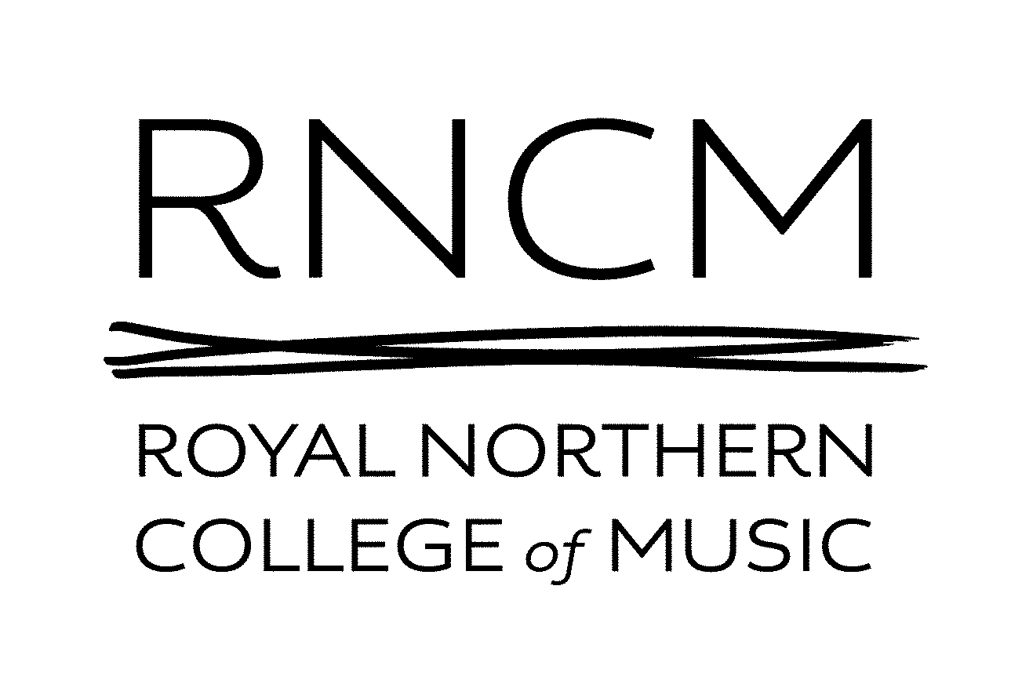

Satisfactory Academic Progress Regulations
Royal Northern College of Music
Undergraduate and Postgraduate Awards
(BMus Honours and BMus; Adv. PgDip/MMus; MPhil/Phd)
The U.S. Department of Education requires institutions of higher education to establish minimum standards of satisfactory academic progress for students receiving Federal aid. Satisfactory Academic Progress (SAP) means the student is proceeding in a positive manner toward fulfilling degree requirements. SAP includes two standards; qualitative and quantitative. Students must meet both standards to continue receiving financial aid.
Royal Northern College of Music is a small UK institution offering just three programmes eligible for US Department of Education Federal aid – Bachelor of Music degree with or without Honours (BMus (Hons) and BMus); Graduate School Taught Programmes leading to Master in Performance and Master of Music awards (MPerf/MMus). As each programme has very different structures, specific SAP requirements for each programme are included in an appendix.
Qualitative
In order to maintain eligibility for financial aid with the qualitative standard, a student must maintain the academic standing necessary to remain at Royal Northern College of Music. Registry will conduct a review at the end of each academic year to determine the student’s successful progress toward obtaining a degree on the basis of the detailed requirement for each programme given in the Appendices.
Students may have their studentship terminated by the appropriate body, if they have not made sufficient academic progress to warrant continuance of study. The student has a right of appeal.
Quantitative
Students on taught programmes are expected to attend all classes including those for principal study tuition. Authorised absences are permitted only when accompanied by evidence from a medical practitioner or prior approval by the student’s Head of School. Unauthorised or persistent absence will be investigated by the Head of School and/or Head of Programme and may lead to refusal to grant reassessment or termination of the studentship.
Students on taught programmes must be approved for progression to the next year of the award by the Board of Examiners, as given in detail in the appendices (A-B).
Financial aid will be disbursed on the first day of each semester. Students who withdraw after that will have their eligibility to retain part of their financial aid calculated on the percentage of the semester attended. Students who attend more than 60% of the term may retain all of their aid. See the section on Return to Title IV (R2T4) below.
Transfer Students
Transfer students’ transcripts, including under exchange arrangements or the ERASMUS scheme, will be received and processed by Registry evaluated by the Course Leader under the RNCM Accreditation of Prior Learning and Exchange Programmes procedures. Those units/modules/awards which are applicable to the degree requirement will be accepted and will be used to award credit only against the RNCM degree up to a maximum of 50% of the degree programme.
Appeals and Waivers of SAP
Students have the right of appeal as detailed in the appropriate appendix.
Students who are readmitted to their program may apply in writing to the Assistant Head of Registry (Student Finance and Wellbeing) to continue receiving financial aid. Assistant Head of Registry (Student Finance and Wellbeing) shall consult with the Head of Registry and determine whether to continue financial aid. If the student still does not make satisfactory progress, then he or she will be ineligible for future aid. Normally a student permitted to return on academic grounds shall be approved for financial aid.
UNITED STATES DEPARTMENT OF EDUCATION
RETURN TO TITLE IV (R2T4) REGULATIONS
The law specifies how Royal Northern College of Music must determine the amount of Title IV program assistance (Stafford Loans) that students earn if they withdraw from school. See section on Withdrawals for specific information regarding Leaves of Absence (LOA) and the withdrawal process. The Assistant Head of Registry (Student Finance and Wellbeing) is responsible for calculating R2T4 and transferring the funds. The Assistant Head of Registry (Student Finance and Wellbeing) uses worksheets and software provided by the US Department of Education to calculate the R2T4 funds. All funds must be returned to the lender within 45 days of the last date of attendance. If you have questions about your Title IV program funds, students can call the Federal Student Aid Information Centre at 1-800-4-FEDAID (1-800-433-3243). TTY users may call 1-800-730-8913. Information is also available on Student Aid on the Web at www.studentaid.ed.gov.
When a student withdraws during a payment period, the amount of Title IV program assistance that has been earned up to that point is determined by a specific formula. The date of withdrawal is agreed by the Assistant Head of Registry (Student Finance and Wellbeing) on the Withdrawal of Studies form and is the date of which the student intends to withdraw. If the student received (or the RNCM received on the student’s behalf) less assistance than the amount that earned, the student may be able to receive those additional funds. If the student received more assistance than was earned, the excess funds must be returned by the school and/or the student.
RNCM requires attendance for all scheduled classes and registers will be. Students who are not in attendance are reported, and ultimately the Head of Registry shall determine whether a studentship is terminated on grounds of non-attendance. Without an official Withdrawal Form, the College will use the last date of attendance to compute the R2T4 formula.
In the case where a student notifies the Course Leader or a faculty member that he or she intends to withdraw, the student must be informed of the need to complete the Official Withdrawal Form, document the date the student notified them and share that information with the Assistant Head of Registry (Student Finance and Wellbeing). Should the student fail to file the Withdrawal Form or there is a lag between the notification and the filing of the form, the earlier date of notification will be used in calculating the R2T4 formula.
The amount of assistance earned is determined on a pro rata basis. The payment period is the semester for which the loan was certified and the percent of attendance is calculated by dividing the number of day attended by the total number of days in the payment period. For example, if the student completes 30% of the payment period or period of enrolment, the student has earned 30% of the assistance they were originally scheduled to receive. Once the student has completed more than 60% of the payment period or period of enrolment, all the assistance that the student was scheduled to receive for that period is considered to have been earned If the student did not receive all of the funds that were earned, he or she may be due a post-withdrawal disbursement. If the post-withdrawal disbursement includes loan funds, the student may choose to decline the loan funds so that additional debt is not incurred. The Assistant Head of Registry (Student Finance and Wellbeing) will use the R2T4 worksheets as provided by the US Department of Education to determine how much of the loan may be retained and how much must be returned.
RNCM may automatically use all or a portion of your post-withdrawal disbursement (including loan funds, if the student accepts them) for tuition fees. For all other RNCM charges, the RNCM needs the student’s permission to use the post-withdrawal disbursement. If the student does not give permission (which some schools ask for at the time of enrolment) the student will not be offered the funds. However, it may be in one’s best interest to allow the school to keep the funds to reduce the debt at the school.
There are some Title IV funds that students were scheduled to receive that cannot be earned once a student withdraws because of other eligibility requirements. For example, if a first-time, first-year undergraduate student has not completed the first 30 days of the program before withdrawal, the student will not earn any William D. Ford Federal Direct Loan funds that he or she would have received had the student remained enrolled past the 30th day. If the student receives (or the school receives on behalf of the student) excess Title IV program funds that must be returned, the school must return a portion of the excess equal to the lesser of:
1. The institutional charges multiplied by the unearned percentage of the funds, or
2. The entire amount of excess funds.
The school must return this amount even if it did not keep this amount of the Title IV program funds. If the school is not required to return all of the excess funds, the student must return the remaining amount. Any loan funds that must be returned, the student repay in accordance with the terms of the promissory note. That is, scheduled payments are made to the holder of the loan over a period of time. Students who have received a refund of their loan proceeds before withdrawing may be required to return part or all of those funds to the lender.
Title IV funds will be returned in the following order:
1. Unsubsidized Federal Stafford Loans
2. Subsidized Federal Stafford Loans
3. Federal PLUS Loans
The requirements for Title IV program funds when students withdraw are separate from any refund policy that the school may have. Therefore, the student may still owe funds to the school to cover unpaid institutional charges. The school may also charge for any Title IV program funds that the school was required to return. Student may receive a copy of the refund Policy from the Registry Office or Moodle.
If you have questions about your Title IV program funds, you can call the Federal Student Aid Information Centre at 1-800-4-FEDAID (1-800-433-3243). TTY users may call 1-800-730-8913. Information is also available on Student Aid on the Web at www.studentaid.ed.gov.
Interruption of Studies (IOS) and Withdrawals
Definitions:
Approved Interruption of Studies (IOS)
An IOS is a temporary interruption in a student's programme of study and is requested through the standard Interruption of Studies Form. IOS refers to the specific time period during a program when a student is not in attendance and will return to complete the programme. Students returning from an IOS will normally be required to undertake a confirmatory audition prior to readmission to the programme.
Unapproved Leaves of Absence
A school may grant a student an IOS that does not meet the conditions to be an approved IOS for Title IV purposes (for example, for academic reasons). However, any IOS that does not meet all of the conditions for an approved IOS is considered a withdrawal for Title IV purposes
Official Withdrawal
A “withdrawal” refers to a student’s intent to completely terminate studies at an institution with no expectation of return. Students who subsequently decide to return to their studies, must re-apply for admission through the RNCM Admissions processes using the UCAS for conservatoires service.
Unofficial Withdrawal
An unofficial withdrawal is one where the school has not received notice from the student that the student has ceased or will cease attending the school
IOS and Withdrawal Request Forms
The form required by RNCM to request an IOS or a Withdrawal is available from the Registry Office.
Approved IOS’s
An IOS must meet certain conditions to be counted as a temporary interruption in a student’s education instead of being counted as a withdrawal requiring a school to perform a Return calculation. If an IOS does not meet the conditions and the student is considered to have ceased attendance and to have withdrawn from the school, the school is required to perform a Return calculation.
In order for an IOS to qualify as an approved IOS –
1. All requests for IOS’s be submitted in writing to the Student Finance and Records Administrator and include the reason for the student’s request. The form must be signed and dated by the student and specify the date the student wants the IOS to begin and end.
2. Students must apply in advance for an IOS unless unforeseen circumstances prevent the student from doing so.
3. The situation described for the reason for the IOS must be generally non-academic in nature and must be one that leads to a reasonable expectation that the student will return from the IOS within the allowed time frame.
4. The IOS together with any additional leaves of absence must not exceed a total of 180 days in any 12-month period including days in which school is not is session.
All requests for IOS’s will be reviewed by the Head of School, Course Leader, the Assistant Head of Registry (Student Finance and Wellbeing), and will be confirmed by the Head of Registry. The student will be notified in writing by the Student Finance and Records Administrator of the decision to approve.

During the IOS, the institution will not assess the student any additional institutional charges, the student's financial need will not increase, and therefore, the student will not be eligible for any additional disbursements of Federal Student Aid.

If the student is a Stafford Loan recipient, RNCM will explain to the student, prior to granting the IOS, the effects that the student’s failure to return from an IOS may have on the student’s loan repayment terms, including the expiration of the student’s grace period.
A student granted an IOS that meets the criteria stated above is not considered to have withdrawn, and no Return calculation is required. Upon the student’s return from the leave, he or she continues to earn the Federal Student Aid previously awarded for the period.
Completion of coursework upon return
Academic Programmes at the RNCM are normally for a full academic year even if the disbursement of funding is based on a term or semester. A student returning from an IOS must do so at a time when he or she can complete the term in order to complete the payment period and be eligible to receive a second or subsequent disbursement. Therefore, in order for an IOS to be an IOS, the RNCM will allow a student returning from an IOS to complete the coursework that he or she began prior to the IOS.
Students who return earlier than anticipated
Taught programmes at the RNCM are for a full academic year and return from an IOS is not permitted outside the anniversary of the temporary withdrawal.
Student who fail to return from IOS’s
If a student does not return to the school at the expiration of an approved IOS (or a student takes an unapproved IOS), the student’s withdrawal date is the date the student began the IOS.
Explanation of consequences of withdrawal to loan recipients
A student who is granted an approved IOS is considered to remain in an in-school status for Title IV loan repayment purposes. If a student on an approved IOS fails to return, the school must report to the loan holder the student’s change in enrolment status as of the withdrawal date. One possible consequence of not returning from an IOS is that a student’s grace period for a Title IV program loan might be exhausted. Therefore, in order for a IOS to be an approved IOS, prior to granting a leave of absence, a school must inform a student who is a Title IV loan recipient of the possible consequences a withdrawal may have on the student’s loan repayment terms, including the exhaustion of the student’s grace period.
Unapproved IOS’s
A school may grant a student an IOS that does not meet the conditions to be an approved IOS for Title IV purposes (for example, for academic reasons). However, any IOS that does not meet all of the conditions for an approved IOS is considered a withdrawal for Title IV purposes. The student’s withdrawal date is the date the student begins the IOS. An unapproved IOS may be treated as an official withdrawal since the school would have previously granted an IOS. Therefore, the school would know immediately that the student had ceased attendance for Title IV purposes, and must use the specified withdrawal date in the Return calculation.
Adam Croucher
Assistant Head of Registry (Student Finance and Wellbeing)
October 2015

Appendix A – Specific Programme Requirements for Satisfactory Academic Progress for students studying for the Bachelor of Music (BMus) and Bachelor of Music with Honours (BMus Hons) degree of Royal Northern College of Music
The BMus degrees require students to pass 120 credits in each of years 1 and 2 (Levels 4 and 5 of the Framework for Higher Education Qualifications in England, Wales and Northern Ireland (FHEQ)). Students must pass all units of the programme, save that compensation rules apply for the four ten-credit units in each year, such that an overall satisfactory progress can be recorded if the student has at least 40% weighted average in both the four units and overall and at least 30% in any units not achieved as well as passing the remaining elements of the programme.
Students taking year 3 (level 6 of the FHEQ) must pass at least 120 credits to progress to an Honours degree and at least 100 credits to progress to a BMus degree (without Honours). There is no compensation permitted for failed units at Level 6.
The pass mark is 40% for all units on the BMus. Students may be permitted a resit for a failed unit at the discretion of the Board of Examiners, which shall take into account attendance on the unit.
Students who have a notified disability may have special arrangements for assessment, including alternative forms of assessment (as permitted under the UK Equality Act 2010). Students who have special circumstances of an unanticipated nature (e.g. a period of illness, bereavement, or a temporary impairment affecting them attending or submitting for an assessment) may submit an application for a deferral of an assessment or other modification to the assessment method, such as an extension, to the Extenuating Circumstances Panel (ECP). No application can be submitted without written evidence such as a medical certificate. The ECP shall consider each application anonymously and determine the revised arrangements for reassessment but is not permitted to modify student marks.
Students may have their studentship terminated by the Board of Examiners at the end of any academic year, if they have not made sufficient academic progress to warrant continuance of study. The Board of Examiners may also determine that a student should be permitted to resit the entire year, in which case the previous marks are expunged from the programme record and the student repeats the year as if for the first time.
The student has a right of appeal to the Appeals Committee of the Board of Examiners whose decision shall be final. A student appeal is not permitted to question the academic judgement of the examiners in awarding marks.
Student assessments believed to represent Academic Malpractice, including plagiarism and collusion, are referred to an Academic Malpractice Committee established by the Board of Examiners, which will investigate and may determine an appropriate penalty for the unit, or for the whole programme if very serious.
The maximum allowable time to be eligible for financial aid for a full-time BMus degree student is six academic years regardless of whether the students receives Federal Student Aid (loans) during any enrolment period.
The normal time frame for completion of a BMus degree is four years.
Exceptionally, a student undertaking an accelerated degree (three years) shall be required to present evidence prior to entry of a high level or preparedness equivalent to three Grade As in the General Certificate of Education, a performance qualification equivalent to the Diploma of the ABRSM, and the ability to benefit from an accelerated programme, and shall follow similar consideration of progress by the Board of Examiners but may be moved to the standard version of the programme if they are not making a sufficiently high level of progress through the units.
Royal Northern College of Music evaluates Satisfactory Academic Progress at the end of the academic year. For most students this is in July but for a student with an approved deferral or referral in a unit this will be in September. Students must complete all required units by the end of the degree. Students who achieve a passing grade may not repeat a unit. No repeat of a failed unit is permitted unless the student is repeating the entire year of study. There are no non-credit remedial units for students entering year 1 after September 2011. Scheduled classes for the next academic year for students whose studentship is terminated because they are not making Satisfactory Academic Progress will be cancelled.
Change of Programme or Degree
There are no other degree programs that students can transfer to (other than between the honours and non-honours programmes).
Concurrent Degrees
There are no concurrent degrees, but students may also be entered for advanced awards of the Associated Board of the Royal Schools of Music (ABRSM), LRSM and FRSM, as part of their programme of assessment, and receive both a degree and an ABRSM award concurrently.

Appendix B – Specific Programme Requirements for Satisfactory Academic Progress for students studying for the Master of Performance (MPerf) and Master of Music (MMus) degrees of Royal Northern College of Music
The Master in Performance and Master of Music (MPerf and MMus) degree is normally two years but may be taken in 12 months for exceptionally high standard of students. All the degrees are at level 7 of the Framework for Higher Education Qualifications in England, Wales and Northern Ireland (FHEQ).
Students must pass all units of the programme. To progress from year one of the two year MPerf and MMus to the second year, the student must pass 60 credits and have taken a formative assessment (recital or composition) equivalent to 60 credits but not counting towards the degree award or classification. In the second year the student must pass 120 credits, 180 credits overall.
The pass mark is 50% for all units on the MPerf/MMus. Students may be permitted a resit for a failed unit at the discretion of the Board of Examiners, which shall take into account attendance on the unit.
Students who have a notified disability may have special arrangements for assessment, including alternative forms of assessment (as permitted under the UK Equality Act 2010). Students who have special circumstances of an unanticipated nature (e.g. a period of illness, bereavement, or a temporary impairment affecting them attending or submitting for an assessment) may submit an application for a deferral of an assessment or other modification to the assessment method, such as an extension, to the ECP. No application can be submitted without written evidence such as a medical certificate. The ECP shall consider each application anonymously and determine the revised arrangements for reassessment but is not permitted to modify student marks.
Students may have their studentship terminated by the Board of Examiners at the end of any academic year, if they have not made sufficient academic progress to warrant continuance of study. The Board of Examiners may also determine that a student should be permitted to resit the entire year, in which case the previous marks are expunged from the programme record and the student repeats the year as if for the first time.
The student has a right of appeal to the Appeals Committee of the Board of Examiners whose decision shall be final. A student appeal is not permitted to question the academic judgement of the examiners in awarding marks.
Student assessments believed to represent Academic Malpractice, including plagiarism and collusion, are referred to an Academic Malpractice Committee established by the Board of Examiners, which will investigate and may determine an appropriate penalty for the unit, or for the whole programme if very serious.
The maximum allowable time to be eligible for financial aid for a full-time MPerf or MMus degree student is three calendar years (36 months) regardless of whether the students receives Federal Student Aid (loans) during any enrolment period.
The normal time frame for completion of an MPerf or MMus degree is two calendar years (24 months) but may also be completed in one calendar year (12 months) for exceptional students.
Royal Northern College of Music evaluates Satisfactory Academic Progress at the end of the academic year. For most students this is in July but for a student with an approved deferral or referral in a unit this will be in September. Students must complete all required units by the end of the degree. Students who achieve a passing grade may not repeat a unit. No repeat of a failed unit is permitted. There are no non-credit remedial. Scheduled classes for the next academic year for students whose studentship is terminated because they are not making Satisfactory Academic Progress will be cancelled.
Change of Programme or Degree
Students may exceptionally transfer between the two year MMus, one year MMus and MPerf, subject to Academic approval by the Course Leader, which must be applied for by 1st November in the academic year in question.
Concurrent Degrees
There are no concurrent degrees.

