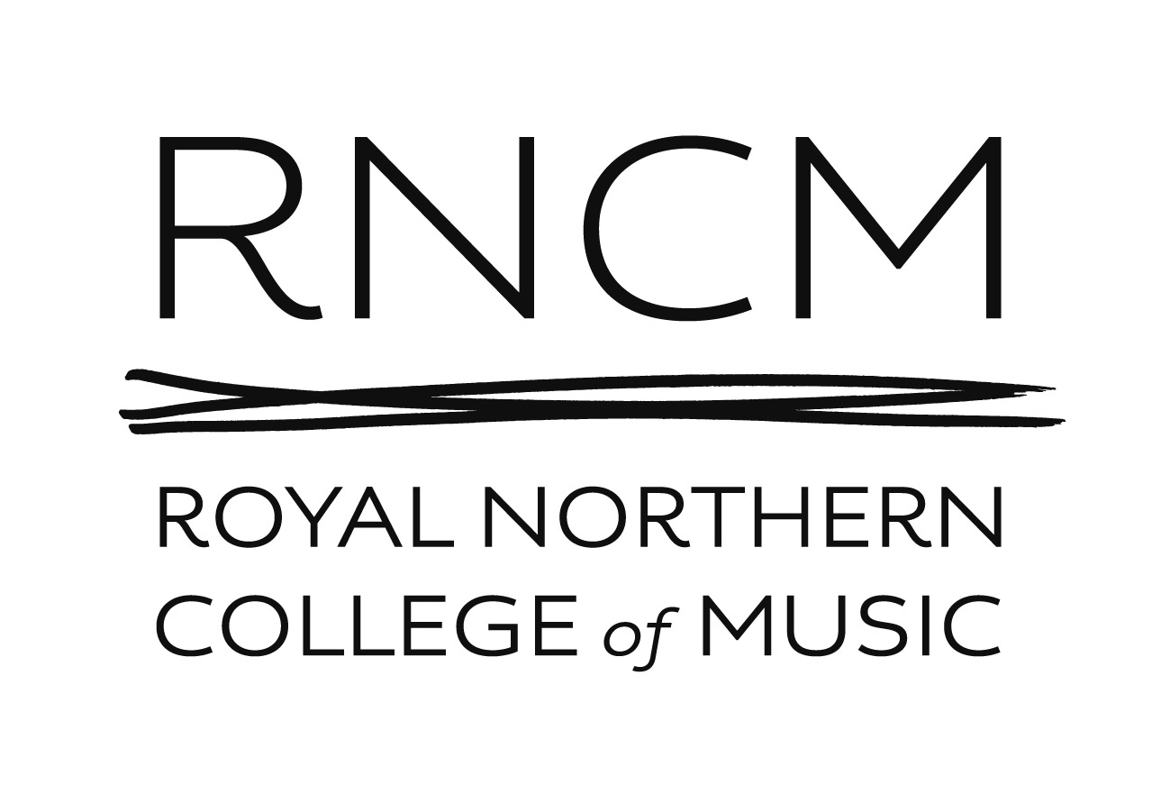

RNCM Young Strings Application Form

Please print or type details below:
Child’s first name
Child’s family name
Date of birth
Name of parent/carer | Mr/Mrs/Miss/Ms
Address

Telephone Number(s) | Mobile
Telephone Number(s) | Home
Email address
Name of school
Musical experience and instruments played
Please give details of any special learning needs, illnesses or allergies
How did you hear about RNCM Young Strings? e.g. word of mouth, website, flyer

Signed ____________________________________ Date__________________________________
(please type if emailing application)

Please return your completed form to Bryony Taylor, Music Education Administrator, Royal Northern College of Music, 124 Oxford Road, Manchester, M13 9RD, or email to bryony.taylor@rncm.ac.uk

